5. Both figures below show the same scale. The marks on the scale have no labels except the zero point.
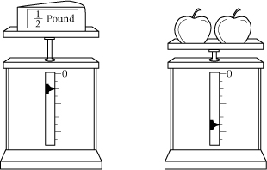
The weight of the cheese is ½ pound. What is the total weight of the two apples?

6. The booster club is planning to buy peanuts to serve at its meetings. The cost of the peanuts depends on the amount purchased, as shown in the table below.
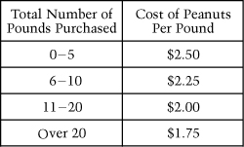
How much will 18 pounds of peanuts cost?

15. If Rose spins a spinner like the one below 300 times, about how many times should she expect it to land on the space with a circle?
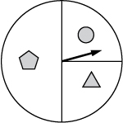
16. If you were to redraw the diagram using a scale of ¾ inch = 10 feet, what would be the length of the side that is 48 feet?
