Lesson plan
Lesson Title (concept) | Budgeting- What can you afford to spend on living expenses?
Instructor | Miss Emily Hahn
Suggested grade level/course | Independent Living, Housing  High School  Grades 11-12
Time suggested | 90 minutes. (1 block)
National Standards addressed:  - State the entire objective, not just the number  State and/or local standards addressed:  - State the entire objective, not just the number | Area of Study 2.0  Consumer and Family Resources  Comprehensive Standard  Evaluate management practices related to the human, economic, and environmental resources.  2.6 Demonstrate management of financial resources to meet the goals of individuals and families across the life span.  2.6.1 Evaluate the need for personal and family financial planning.  2.6.2 Apply management principles to individual and family financial practices.
Rationale for the lesson:  - Where does it fit into the unit plan?  - Why are you choosing this activity/strategies?  - How will you plan for differentiation? | By the end of this unit, the student will, individually, choose an apartment and furnish it within a given budget. Before you can involve yourself with any living situation, you have to know what your resources are. What will your income be? How much can you afford for the basic living expenses?  Today’s class will be spent learning, what exactly is a budget? Why do I need a budget? How do I calculate my personal budget? Once budgeting is figured out, the student will be able to move on to the next step, which would be plugging numbers in to find an apartment.  I am choosing this strategy because it incorporates core curriculum (math), forces the students to think critically, show work, and think realistically about potential resources.  Based on the careers that the students are interested in, their personal work on the second day will vary. Every student will get his or her own experience with career income.  Students that may be gifted or have additional needs in the classroom can be assisted with either an aide, larger type/font for worksheets, and/or will have extended work time for their assessment. Additionally, the worksheet may be completed on the computer for a student that may have an exceptionality.
Content objective:  - What will students know and be able to do at the end of the lesson?  - Is the information or concept new to the students? | By the end of class today, the students will be able to explain the purpose of a budget and factors that are involved in budgeting.  The concept is relatively new to the majority of these students because of their age group. High school students, for the most part, are not familiar with budgeting and having multiple expenses. However, it will bring what they already know about money management to a more realistic point. They can think about their own situations, for example, how many trips to Starbucks can they afford per month and still stay in budget.
Assessment:  - How will you know students can do the above? | The assessment for this day will be a worksheet on budgeting and allowable expenditures based off their chosen career income. This worksheet will force the student to take a critical look at what resources are available to them. They must show their work on this assessment.  A short discussion and/or check for understanding will be incorporated into the end of class.
Procedure/activities

- Intro: Recap day before…have career chosen, know income, what next? (5 minutes)
- Bell Ringer: What is a budget? What purpose do they serve? Think pair share with person next to you (5-10 minutes) (record in one notebook, turn in)
- Essential Question: How do you know what your budget will be? How do you calculate it? (budget pie chart) (10 minutes) show visual
- Activity: Create your own budget pie chart (activity) what will fit in each category? (20 minutes)
  - Scissors
  - Markers
  - Colored pencils
  - Rulers
  - Tape
  - Paper
  - Writing Utensils
- Transition: Now you have outlined your budget expenses, its time to do some math…
- Assessment: Budget worksheet (30 minutes)
- Essential Question/Discussion/Wrap Up: Discuss (essential questions) Why do you rent an apartment? How is this a different financial situation than when budgeting for a house? (10 minutes)

References and resources | Budget Pie Chart: http://www.maillardvillemanor.com/2010_07_01_archive.html  Occupational Outlook Handbook (should it need to be referred back to)  http://www.bls.gov/ooh/  Budget worksheet copied below
Include attachments of any handouts, assessments, and/or powerpoints, etc.

What can YOU afford to spend?
Directions: Read the information provided below in order to complete the questions on the second page.
15 points total
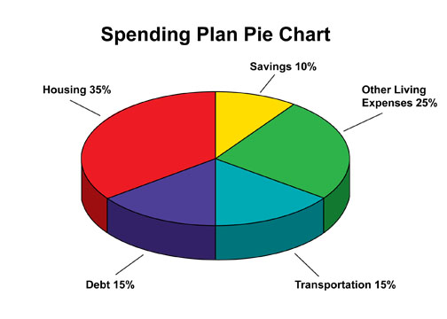
http://www.maillardvillemanor.com/2010_07_01_archive.html
Key:
- Housing: rent, mortgage, property taxes, etc (This ranges from 30-35%)
- Savings: how much you should be saving each month
- Other living expenses: entertainment (movies, going out to eat)
- Debt: student loans, other loans
- Transportation: gas, car payment, car insurance, public transportation
Using the chart above, answer the following questions. Make sure to show your work.
Hint: to calculate, take the percentage of the pie chart, multiple that by your income, and then subtract that number out to get your new net income.

Example: If my take-home pay each month is $2,000, I need to multiply that by .35 to figure out how much I can afford for rent. Make sure to then subtract that number out to get to the next category.
2,000x.35=$700….so I can afford $700 per month and have $1300 left for the rest of my budget
Complete the following questions and be sure to SHOW ALL of YOUR WORK.

- What is your median income for the career you chose? __________

- Calculate out 20% of your income for taxes. What is your new income? ________

- Divide that number by 12 to get your monthly net income ______

- How much can you afford to spend on rent each month? ___________

- Did your career require a college degree? If yes, how much will you need to budget for your student loans each month? If no, add that to savings. ____________

- How much are you able to budget for transportation costs? __________

- After figuring out those parts of your budget, do you have anything left over to put in savings? If yes, how much? If no, what could you do to change that? ____________________________________________________________
____________________________________________________________

8. After completing this activity, what was most surprising to you?

