What can YOU afford to spend?

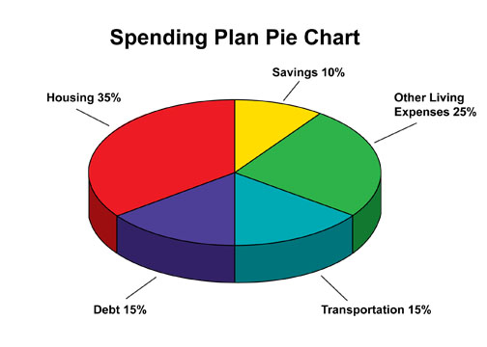
http://www.maillardvillemanor.com/2010_07_01_archive.html
Key:
- Housing: rent, mortgage, property taxes, etc
- Savings: how much you should be saving each month
- Other living expenses: entertainment (movies, going out to eat)
- Debt: student loans, other loans
- Transportation: gas, car payment, car insurance, public transportation
Using the chart above, answer the following questions. Make sure to show your work.
Hint: to calculate, take the percentage of the pie chart, multiple that by your income, and then subtract that number out to get your new net income.
Example: If my take-home pay each month is $2,000, I need to multiply that by .35 to figure out how much I can afford for rent. Make sure to then subtract that number out to get to the next category.
2,000x.35=$700….so I can afford $700 per month and have $1300 left for the rest of my budget

- What is your median income for the career you chose? __________

- Calculate out 20% of your income for taxes. What is your new income? ________

- Divide that number by 12 to get your monthly net income ______

- How much can you afford to spend on rent each month? ___________

- Did your career require a college degree? If yes, how much will you need to budget for your student loans each month? If no, add that to savings. ____________

- How much are you able to budget for transportation costs? __________

- After figuring out those parts of your budget, do you have anything left over to put in savings? If yes, how much? If no, what could you do to change that? ____________________________________________________________
__________________________________________________________________

8. After completing this activity, what was most surprising to you?

