Housing and Interiors
Floor Planning Worksheet
Name__________________________
- List some ABSOLUTE needs in housing.

- List some housing wants.

- What are the three main areas (zones) of the home?

- What is circulation?

- Define floor plan.

- Define family circulation and list 3 principles that good patterns should follow.

- Define work circulation and list 3 principles that good patterns should follow.

- Define service circulation and list 3 principles that good patterns should follow.

- Define guest circulation and list 3 principles that good patterns should follow.

- Label the living, sleeping, and service zones throughout this floor plan
- Label circulation patterns:
  - Family- red colored pencil
  - Work- green colored pencil
  - Service- blue colored pencil
  - Guest- purple colored pencil
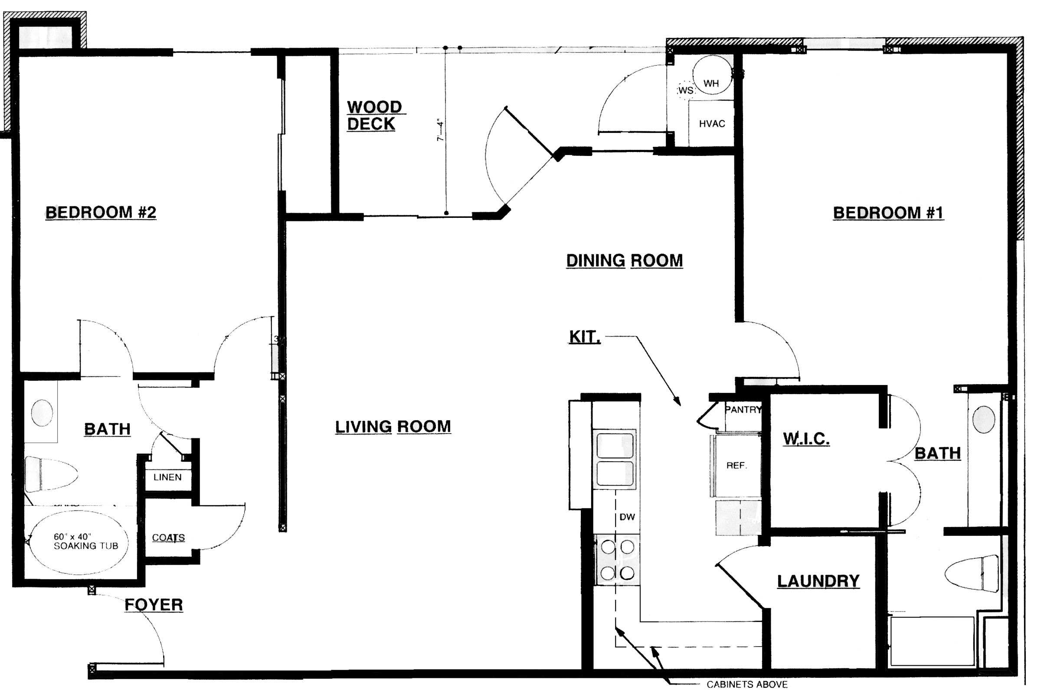
- Is this an effective floor plan? Why or why not?

Adapted from: http://www.uen.org/Lessonplan/preview.cgi?LPid=5752

