Physical and Psychological Needs
Housing Definition:

Maslow’s Hierarchy of Needs:

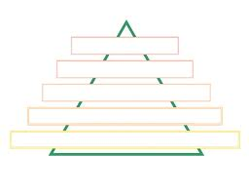

Physical Needs: How are these needs met through housing?
Shelter
Food

Psychological Needs: How are these needs met through housing?
Security
Love and Acceptance
Esteem
Self Actualization
Beauty
Self-expression
Creativity

