Lesson plan
Lesson Title (concept) | Circulation and Floor Plans
Instructor | Amber Terwilleger
Suggested grade level/course | High School / Interior Design
Time suggested | 45 minutes
National Standards addressed:  - State the entire objective, not just the number  State and/or local standards addressed:  - State the entire objective, not just the number | STANDARD 11: Integrate knowledge, skills, and practices required for careers in housing and interior design.
Rationale for the lesson:  - Where does it fit into the unit plan?  - Why are you choosing this activity/strategies?  - How will you plan for differentiation? | This lesson plan is the first lesson of the Floor Plan and Circulation Unit. It introduces the idea of movement within the household.  This lesson will help students understand how furniture placement and door placement can impact circulation, and how different people can have different needs and their circulation pattern can change.  I will plan to physically show students the circulation of a room by giving them different purposes (e.g. just brought home groceries, must clean the windows, must gather laundry, etc) to show them different patterns.
Content objective:  - What will students know and be able to do at the end of the lesson?  - Is the information or concept new to the students? | Students will be able to differentiate circulation patterns and plan furniture placement based on the different types of circulation.  The concept may be familiar to students, even if they didn’t know the terms for it.
Assessment:  - How will you know students can do the above? | Students will be assessed on their final floor plan, their involvement in drawing a circulation line, and their participation in class discussion.
Procedure/activities

(5 minutes) Ask students if they have heard of circulation and in what context. Anticipate answers such as blood circulation or others of this fashion. Ask students to relate the idea of circulation to a house, and what would circulation mean here? Anticipate answers such as heating and cooling or air flow.

(15 minutes) Introduce circulation as “walking patterns” within a household. Open textbooks to Chapter Two (page 27). Throughout the week, we will be discussing living areas, sleeping areas, service areas, and typical circulation patterns within those rooms.

Looking at a floor plan where all of the sleeping, living, and service areas are together, what are some pros and cons to this type of floor plan? (small group/partner discussion, then large group discussion)
Now look at the floor plan where the sleeping and service areas are divided. What are some pros and cons of this floor plan? (small group/partner discussion, then large group discussion)

(10 minutes) In your notebooks, make sure you have definitions for:
Circulation: the route that people follow as they move from one place to another in the home.
Circulation frequency: the number of times a route is repeated in any given period.

Example: Think about the frequency of circulation and what impact that might have on your choice of floor plan. If I have an apartment, and I live alone in a one bedroom, one bath, it may not be a big deal to have the bathroom entry in my room. However, if I like to host study groups, which apartment floor plan would probably be better if I want to keep my privacy and people out of my bedroom?

However, if I tend to go my friends’ homes rather than having them over to my place, there would be a smaller amount of guest circulation. The placement of the bathroom may be less of an issue.

(15 minutes) The most frequent and complex circulation pattern will most often be family circulation because there are typically so many family members who have different motivations to move throughout the house.

Work circulation includes the kitchen, laundry, basement, garage, and storage area. Within the kitchen, you should be able to move from the sink, cooking units, and refrigerator. Why would it be important for the kitchen and dining area/room to be in close range without any extra cross traffic?

Service circulation includes service/maintenance calls, deliveries, meters, and other services. This circulation can be done by family members or by others.

Guest circulation includes access from the door way to the living room, dining room, and bathroom. Guest circulation should not have to move through any other rooms. Guests should travel through the least amount of rooms possible.

(Remaining time of the class) Draw up a rough floor plan of your house, and map out a typical circulation pattern including service, family, and guest circulation.

References and resources
Include attachments of any handouts, assessments, and/or powerpoints, etc.
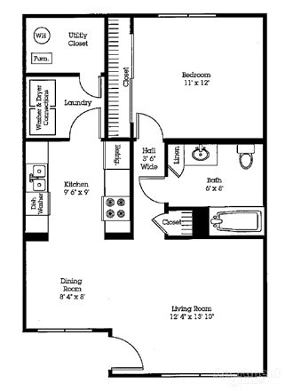

Sherwood
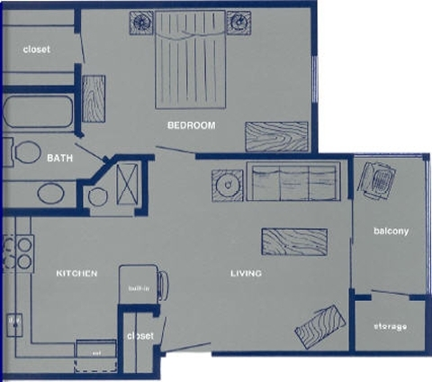

Vanderbilt

